My Album
My project is about album of pictures. You can manage your pictures, search pictures, see other one’s pictures, evaluate other one’s pictures, and make friends and so on.
The techniques I used are Grails, Jquery, and Css.
Screenshots
1、First Page
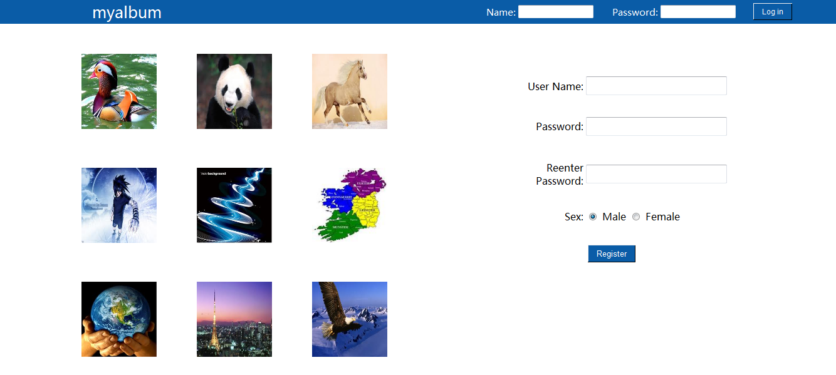
The left part is the best nine pictures which are sorted by prefer_value. I can direct use the domain class, because I use this <%@ page import="ourAlbum.*" %> in my index page.
In the first page, you can log in and register.

2、Home Page
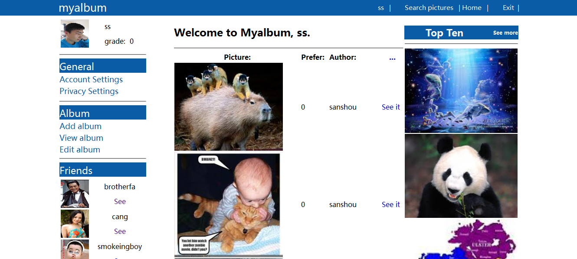
I hidden the account settings, privacy settings, add album, and the detail of top ten. When you click them, I use Jquery to display it in the middle part.
In the top part, you can see the name of the website, your user name, some hyperlink, and exit. In this place, I give seesion to them, and to the contrary, I give normal object to other parts. So I can see other one’s page and return to my page.
In the left part, it will show user’s image, name and grade. Account settings can change password. Privacy settings can change your detail information. Add album can add an album, and then you can add pictures in this album. View album can see all of your albums. Then, the Friends show all of your friends, you can click see to see your friend.
In the middle part, the default information is the newest pictures, you can click see it to see the detail information of the picture.
In the right part, it’s the best ten pictures. You can click see more to see them in the middle part, and then you can choose to see the detail information of each picture.

3、Search picture page
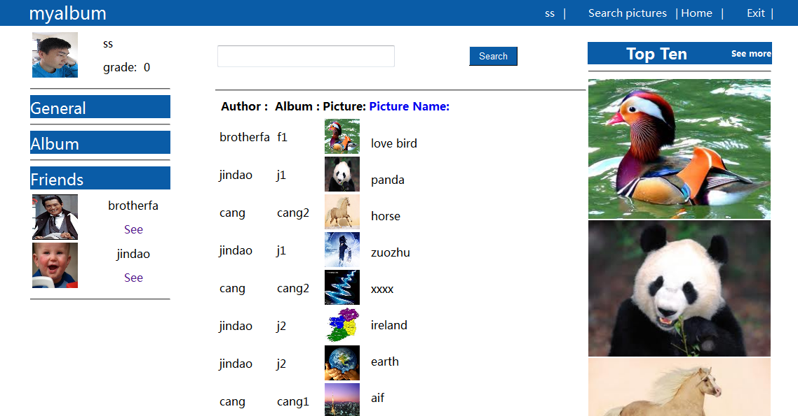
In this page, every thing is same as the Home page, except the middle part, you can search pictures according to their name.

4、Other one’s page
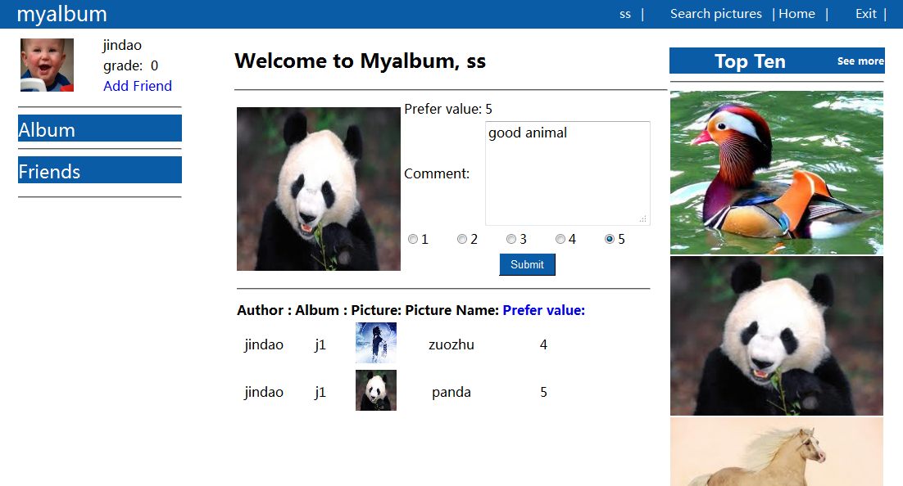
In this page, it will show the information of other one. You can click the picture of him, and the evaluation part will show in the top of the middle part, and tend you can evaluate it. If you want to add the user to be your friend, you can click Add friend.

Conclusion
Grails is a good tool to develop a website in a short time. If you want to know its power, you can reference this page http://grails.org/doc/latest/ref/Tags/remoteField.html.
At last, you should attention the hsqldb, when you change the configuration of your database; I suggest you should restart your eclipse.

